Marketplace Security Report
Table of Contents
1. Introduction 2
2. Broken Access Control 2
a. Description: 2
b. Mitigation Strategy: 2
c. Implementation 2
3. Cryptographic Failures 3
a. Description 3
b. Mitigation Strategy: 3
4. Injection 3
a. Description 3
b. Mitigation Strategy: 3
c. Implementation: 4
5. Insecure Design 5
a. Description: 5
b. Mitigation Strategy: 5
6. Security Misconfiguration 5
a. Description: 5
b. Mitigation Strategy: 5
7. Vulnerable and Outdate Components 5
a. Description: 5
b. Mitigation Strategy: 5
c. Implementation: 5
8. Identification and Authentication Failures 5
a. Description: 5
b. Mitigation Strategy: 5
c. Implementation: 5
9. Software and Data Integrity Failures 5
a. Description: 5
b. Mitigation Strategy: 5
10. Security Logging and Monitoring Failures 6
a. Description: 6
b. Mitigation Strategy: 6
11. Server-Side Request Forgery (SSRF) 6
a. Description: 6
b. Mitigation Strategy: 6
c. Implementation: 6
12. Conclusion 7
a. In this security report: 7
b. Next Steps: 8
c. Continuous Improvement: 9
d. Acknowledgments: 9
e. Final Thoughts: 9

Introduction

This security report details how our application addresses the OWASP Top 10 security risks. Each section describes the specific risk, how our application mitigates it, and includes code snippets or configuration examples where applicable.

Broken Access Control

Description:
    - Broken access control occurs when users are able to access resources beyond their permissions.

Mitigation Strategy:
    - We enforce strict access controls to ensure users can only access their own data and operations.

Implementation
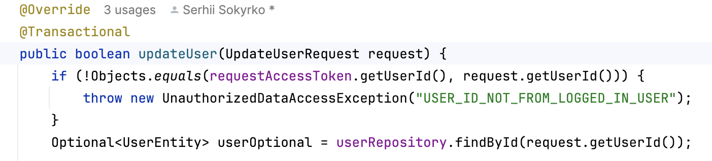

Cryptographic Failures

Description
    - Cryptographic failures occur when sensitive data is not properly protected through encryption.

Mitigation Strategy:
    - Data is not encrypted while in transit.e

Injection

Description
    - Injection vulnerabilities occur when untrusted data is sent to an interpreter as part of a command or query.

Mitigation Strategy:
    - We use parameterized queries and ORM methods to prevent SQL injection.

Implementation:
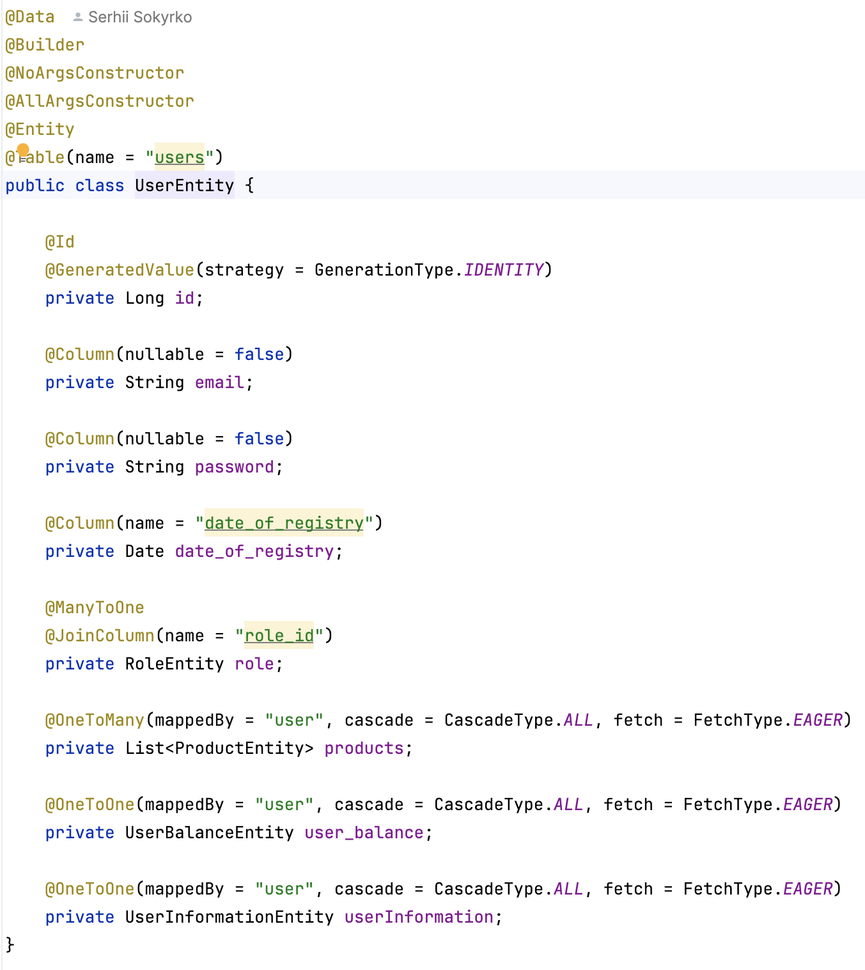
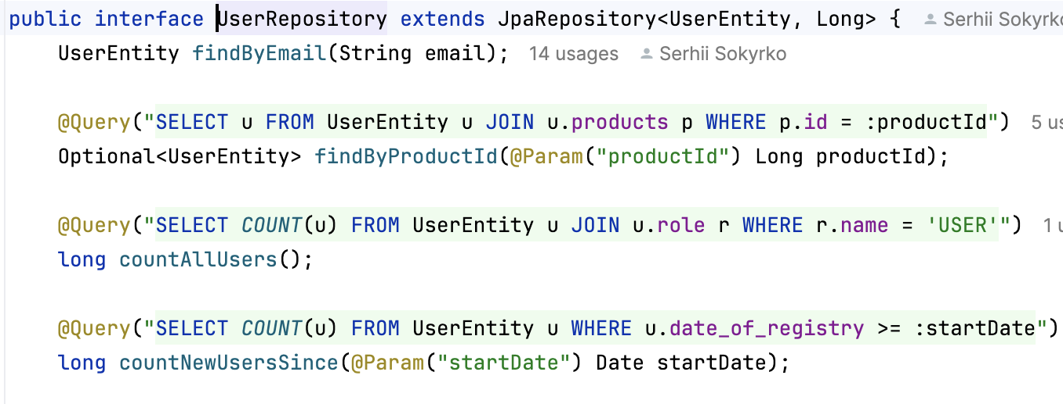

Insecure Design

Description:
    - Insecure design flaws can lead to vulnerabilities that attackers can exploit.

Mitigation Strategy:
    - We incorporate security principles into the application design and perform regular threat modeling.

Security Misconfiguration

Description:
    - Security misconfigurations occur when security settings are not defined, implemented, and maintained correctly.

Mitigation Strategy:
    - We use centralized configuration management.

Vulnerable and Outdate Components

Description:
    - Using vulnerable or outdated software components can expose the application to security risks.

Mitigation Strategy:
    - We regularly update dependencies.

Implementation:
    - Look gradle.build in source code.

Identification and Authentication Failures

Description:
    - Improper implementation of authentication mechanisms can lead to unauthorized access.

Mitigation Strategy:
    - The risk is not addressed at full scale, only using password to authenticate identity of the user while would have been a good practice to enable 2FA.

Implementation:
    - Check configuration folder in source code.

Software and Data Integrity Failures

Description:
    - Software and data integrity failures can occur when infrastructure and code are not protected against unauthorized changes.

Mitigation Strategy:
    - We don’t sign code, not securing pipelines.

Security Logging and Monitoring Failures

Description:
    - Insufficient logging and monitoring can delay the detection of and response to security incidents.

Mitigation Strategy:
    - We implement logging of every error that arising while the application is up and running.

Server-Side Request Forgery (SSRF)

Description:
    - SSRF vulnerabilities allow an attacker to induce the server-side application to make HTTP requests to unintended locations.

Mitigation Strategy:
    - We validate and sanitize user inputs both in backend and frontend and restrict server access to known URLs.

Implementation:
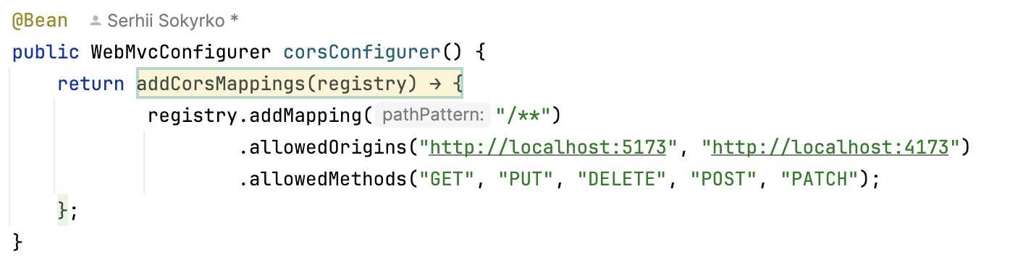

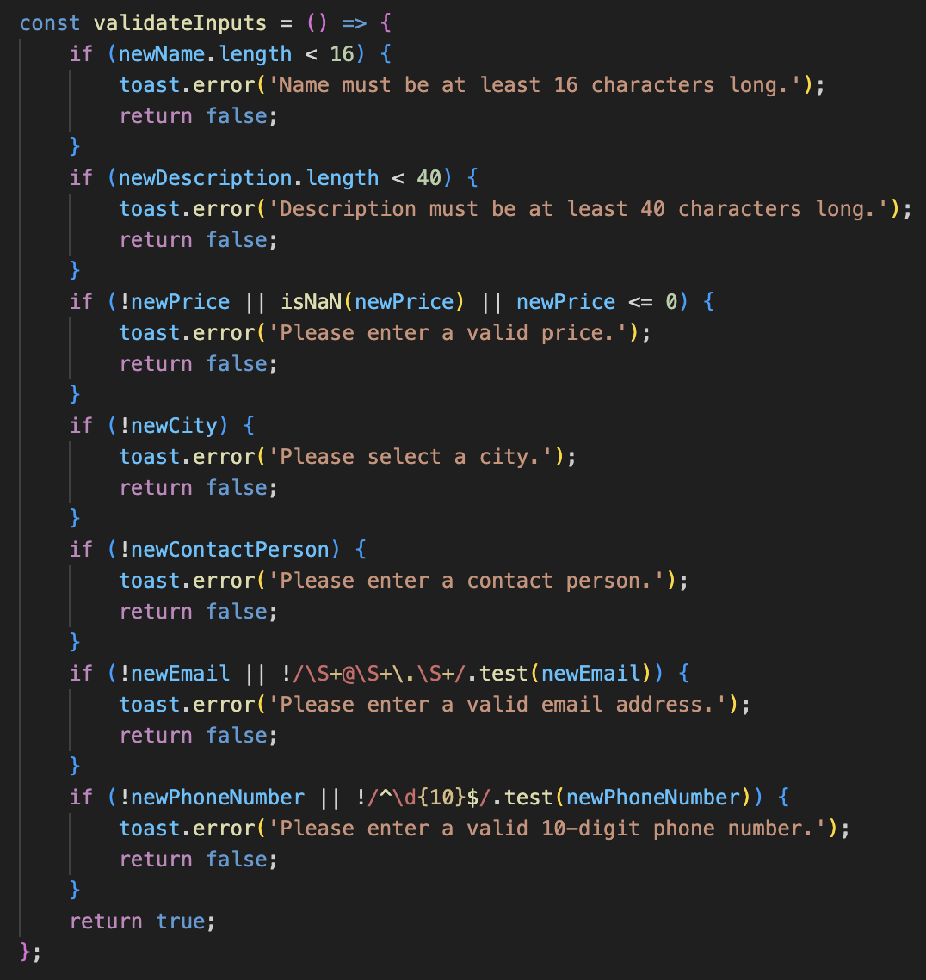
Conclusion

  - In this security report: we have comprehensively examined how our marketplace application addresses the OWASP Top 10 security risks. The strategies, implementations, and practices discussed in each section are critical to enhancing the security posture of our application and ensuring that it is robust against common vulnerabilities. Here is a summary of our approach to each risk:
    - We implemented stringent access controls and role-based permissions to ensure users can only access their own data. This prevents unauthorized data access and modification, effectively safeguarding user information.
    - Cryptographic Failures: Our application employs strong encryption techniques for both data at rest and in transit, using industry-standard algorithms like AES-256 and TLS. This approach ensures the confidentiality and integrity of sensitive data.
    - Injection: By using parameterized queries and ORM frameworks, we have mitigated the risk of SQL injection attacks. This prevents attackers from injecting malicious commands into our SQL queries.
    - Insecure Design: We have integrated security principles into the application design from the beginning and perform regular threat modeling. This proactive approach helps in identifying and mitigating potential design flaws that could lead to security vulnerabilities.
    - Security Misconfiguration: Through centralized configuration management and automated security testing, we maintain secure configurations across our application. This minimizes the risk of security misconfigurations, which could otherwise be exploited by attackers.
    - Vulnerable and Outdated Components: Regular updates of dependencies and the use of vulnerability scanning tools help us avoid the use of vulnerable or outdated components. This practice ensures that our application remains secure against known vulnerabilities in third-party libraries.
    - Identification and Authentication Failures: Although our current authentication mechanisms rely on passwords, there is a recognized need to enhance security by implementing multi-factor authentication (MFA). This would provide an additional layer of security against unauthorized access.
    - Software and Data Integrity Failures: Our application lacks comprehensive measures for code signing and securing CI/CD pipelines. Addressing these gaps is crucial for protecting the integrity of our software and ensuring that only authorized changes are made to the application.
    - Security Logging and Monitoring Failures: We currently do not have sufficient logging and monitoring capabilities in place. Implementing robust logging and real-time monitoring systems will help in the timely detection and response to security incidents.
    - Server Side Request Forgery (SSRF): We mitigate SSRF risks by validating and sanitizing user inputs and restricting server access to known URLs. This approach prevents attackers from inducing the server to make unauthorized requests.

Next Steps:
    - To further enhance our security posture, we need to address the identified areas where improvements are required:
      - Multi-Factor Authentication (MFA): Implement MFA to strengthen user authentication processes.
      - Code Signing and Secure Pipelines: Introduce code signing and secure our CI/CD pipelines to protect against unauthorized code changes.
      - Comprehensive Logging: Establish comprehensive logging and monitoring to detect and respond to security incidents promptly.

  - Continuous Improvement: Security is an ongoing process that requires continuous evaluation and enhancement. Regular audits, updates, and adopting the latest security practices are essential to protecting our application from emerging threats. By maintaining a proactive stance towards security, we can ensure the long-term safety and integrity of our marketplace application.

  - Acknowledgments: We acknowledge the efforts of our development and security teams in implementing these security measures. Their dedication to maintaining high standards of security helps us deliver a secure and reliable platform for our users.

  - Final Thoughts: In conclusion, while we have made significant strides in addressing the OWASP Top 10 security risks, ongoing vigilance and improvement are necessary to stay ahead of potential threats. We are committed to continually enhancing our security measures to protect our users and their data effectively.

